Low-Level APIs:
There are 2 Low-Level APIs:
- RDD (For manipulating distributed data)
- Broadcast Variables and Accumulators (For manipulating shared variables)
When to use Low-Level APIs?
You should generally use the lower-level APIs in three situations:
- You need some functionality that you cannot find in the higher-level APIs; for example, if you need very tight control over physical data placement across the cluster.
- You need to maintain some legacy codebase written using RDDs.
- You need to do some custom shared variable manipulation
Resilient Distributed Datasets (RDDs):
RDD is a core data structure in Spark. Introduced Spark 1.X series and still available in 2.X version.
RDD represents an immutable, partitioned collection of records that can be operated on in parallel.
Every record in RDD is just a Java, Scala or Python object.
As an end user, you will create following 2 types of RDDs,
- Generic RDD
- Key-Value RDD

Creating RDDs:
From a local collection:
- To create an RDD from collection, use parallelize() method on a SparkContext.
- This turns a single node collection into a parallel collection.
- You can also specify the number of partitions while creating the RDD,

From Data Sources:
- RDDs can be created from text files like below,
- Alternatively, you can read in data for which each text file should become a single record. The use case here would be where each file is a file that consists of a large JSON object or some document that you will operate on as an individual:
- In this RDD, the name of the file is the first object and the value of the text file is the second string object.

From DataFrames:
- Use rdd method on a DataFrame to create an RDD,

RDD Transformations:
RDDs are immutable, meaning they cannot be changed after they are created.
Transformations creates a new RDD from the existing one.
Spark will not act on transformations until we call an action.
Transformations are the core of how you express your business logic using Spark.
There are 2 types of transformations,
- Narrow Transformations:
Each input partition will contribute to only one output partition. No shuffling happens in narrow transformations.
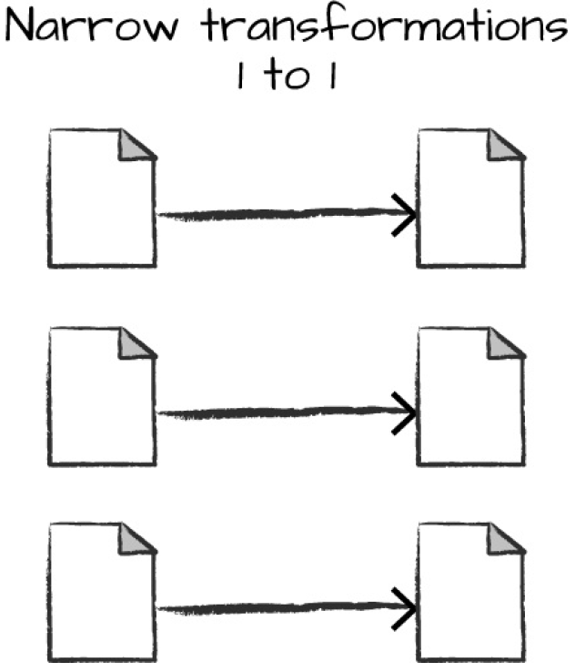
In below example, map() and filter() methods are Narrow transformations.
- Wide Transformations:
Input partition contributes to multiple output partitions. Shuffling happens in wide transformations.
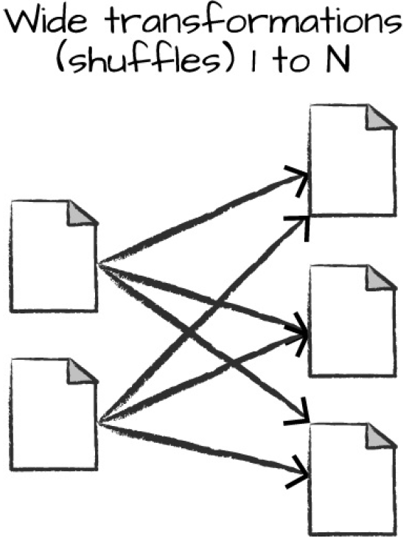
In below example, reduceByKey() is a wide transformation.

Generic RDD Transformations:

map(func):
Returns a new RDD formed by passing each element of a source RDD to a function func.
Example:
flatMap(func):
Return a new RDD by first applying a func to all elements of this RDD, and then flattening the results.
flatMap = map + flattening
Example:

filter(func):
Return a new RDD formed by selecting those elements of the source RDD on which func returns true.
Example:

mapPartitions(func):
Similar to map, but runs separately on each partition (block) of the RDD. So, func must take partition as input.
Example:

mapPartitionsWithIndex(func):
Similar to mapPartitions, but func also takes index of the partition along with partition data.
Example:

union(otherRDD):
Return a new dataset that contains the union of the elements in the source dataset and the argument.
Example:
intersection(otherDataset):
Return a new RDD that contains the intersection of elements in the source dataset and the argument.
Example:

distinct():
Return a new dataset that contains the distinct elements of the source dataset.
Example:

For more information, refer following official documentation page.
https://spark.apache.org/docs/latest/rdd-programming-guide.html#transformations

Actions:
- To trigger the computation, we run an action.
- An action instructs Spark to compute a result from a series of transformations.
- There are three kinds of actions:
- Actions to view data in the console
- Actions to collect data to native objects in the respective language
- Actions to write to output data

count()
Return the number of elements in the dataset.

first()
Return the first element of the dataset.

take(n)
Return an array with the first n elements of the dataset.
Example:

reduce(func)
Aggregate the elements of the dataset using a function func.
Example:

countByKey()
Only available on RDDs of type (K, V). Returns a hashmap of (K, Int) pairs with the count of each key.
Example:

foreach(func)
Run a function func on each element of the dataset. This is usually done for side effects such as updating an Accumulator or interacting with external storage systems.
Example:

collect()
Return all the elements of the dataset as an array at the driver program.
Example:

saveAsTextFile(path)
Write the elements of the dataset as a text file (or set of text files) in a given directory in the local filesystem, HDFS or any other Hadoop-supported file system.
Example:

